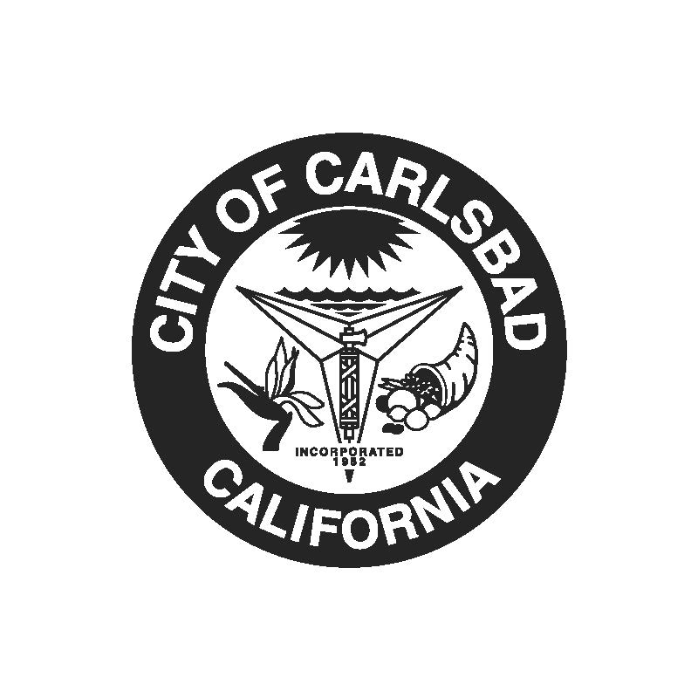

NOTICE OF PUBLIC REVIEW AND
PUBLIC HEARING

NOTICE IS HEREBY GIVEN, the City Council of the City of Carlsbad will hold a public hearing at the Council Chamber, 1200 Carlsbad Village Drive, Carlsbad, California, at 5 p.m. on Tuesday, Oct. 18, 2022, for the City of Carlsbad Permanent Local Housing Allocation (PLHA) Plan. The PLHA plan summarizes the eligible activities to which PLHA funds are proposed over a five-year period.

The PLHA plan is available for public comment and review during a 10-day period, from Oct. 07, 2022 through Oct. 18, 2022. All interested persons are encouraged to submit written comments during the review period, or at the public hearing.

The PLHA plan can be found on the City’s website at www.carlsbadca.gov/city-hall/grants-assistance/cdbg or by contacting Nicole Piano-Jones at nicole.pianojones@carlsbadca.gov or at (442) 339-2191.

Those persons wishing to speak on this proposal are cordially invited to attend the public hearing. Copies of the staff report will be available by Friday, Oct. 14, 2022. If you have any questions, please contact the Housing & Homeless Services Department at (442) 339-2191 or nicole.pianojones@carlsbadca.gov. The meeting can be viewed online at https://www.carlsbadca.gov/city-hall/meetings-agendas or on the city’s cable channel. In addition, written comments may be submitted to the City Council at or prior to the hearing via U.S. Mail to the attention of Office of the City Clerk, 1200 Carlsbad Village Drive, Carlsbad, CA 92008, or via email to clerk@carlsbadca.gov. The hearing will commence at 5 p.m. or as soon thereafter as the matter can be heard. For questions or more information, please contact Nicole Piano-Jones, Program Manager at nicole.pianojones@carlsbadca.gov or at (442) 339-2191.

PUBLISH: October 7, 2022

CITY OF CARLSBAD
CITY COUNCIL

