**AFFORDABLE HOUSING – Carlsbad CA**

(for informational purpose only)

**Zip Codes: 92008, 92009, 92010 & 92011**

## BLUWATER APARTMENTS

6797 Embarcadero Lane

Carlsbad, CA 92011

619-200-8607

12-affordable studio apartments approximately 800 square feet. Included in a mixed- use development. Households earning up to 80% of the AMI*.

## CARLSBAD SUNSET SENIORS

1003-1011 Chinquapin Avenue

Carlsbad, CA 92008

760-729-0311

36 one-bedroom units for seniors 55+.

## CASA ALDEA

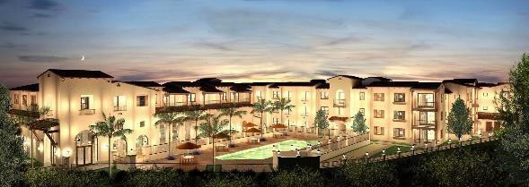2615 Cannon Road

Carlsbad, CA 92008

858-784-0171

98 total units, 20-affordable to senior (55+) households earning up to 80% of the AMI*.

## CARLSBAD VILLAGE LOFTS

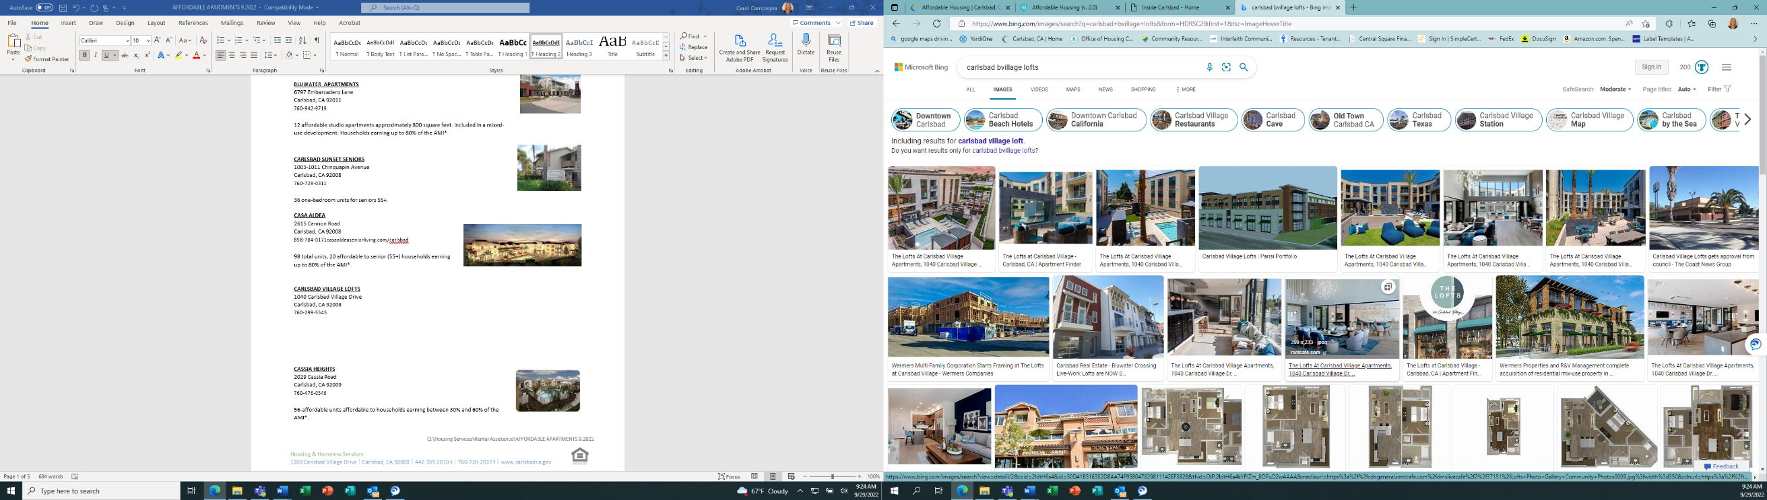1040 Carlsbad Village Drive

Carlsbad, CA 92008

760-299-5545

16-affordable units: one, two & three bedroom units affordable to Households earning up to 80% of the AMI*.

## CASSIA HEIGHTS

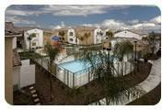2029 Cassia Road

Carlsbad, CA 92009

760-476-0546

56-affordable units, affordable to households earning between 30% and 60% of the AMI*.

## COSTA POINTE

7600 Sitio Del Mar

Carlsbad, CA 92008

760-753-0202

9 affordable units; two, three & four bedroom units affordable to Households earning up to 80% of the AMI*.

## GLEN RIDGE APARTMENTS

3555 Glen Avenue

Carlsbad, CA 92010

760-729-0700

78-unit affordable housing complex affordable to households earning 35%, 50% and 55% of the AMI*.

## HUNTER’S POINTE

7270 Calle Plata

Carlsbad, CA 92009

760-744-5766

168-unit apartment complex; one, two & three bedroom units affordable to households earning 35%, 50% and 55% of the AMI*.

## JEFFERSON HOUSE I

3090 Jefferson Street

Carlsbad, CA 92008

760-729-2810

48 units, one-bedroom units for seniors 55+.

## JEFFERSON HOUSE II

2848 Jefferson Street

Carlsbad, CA 92008

760-434-6026

57 units; 51 one-bedroom units, 6 two-bedroom units for seniors 55+.

## JUNIPER AT THE PRESERVE

2965 Luiseno Way

Carlsbad, CA 92010

760-434-2623

63 affordable units; one, two & three bedroom units affordable to households earning 50% and 60% of the AMI*.

## LA COSTA PALOMA

1953 Dove Lane

Carlsbad, CA 92009

760-476-9860

180-unit apartment complex; one, two, three & four bedroom units affordable to households earning 50%and 60% of the AMI*.

## LAUREL TREE APARTMENTS

1307 Laurel Tree Lane Carlsbad, CA 92011

760-918-1780

138-unit complex; two, three & four bedroom units affordable to households earning 40% to 50% of the AMI*.

## MARBELLA APARTMENTS

2504 Marron Road

Carlsbad, CA 92010

760-434-7368

143-unit complex; 29 affordable units, one, two & three bedroom units affordable to households earning 60% of the AMI*.

## MARIPOSA APARTMENTS

4651 Red Bluff Place Carlsbad, CA 92010

760-729-9300

106-unit apartment complex; one, two & three bedroom units affordable to households earning 20% to 60% of the AMI*.

## PACIFIC VIEW APARTMENTS

5162 Whitman Way

Carlsbad, CA 92008

760-931-5825

111 affordable units affordable to households at 80% of the AMI*; 340 market- rate units.

## POINSETTIA STATION

6811 Embarcadero Lane

Carlsbad, CA 92011

760-438-8839

92-unit complex; one, two & three bedroom units affordable to households earning 60% of the AMI*.

## PORTOLA SENIOR APARTMENTS

2600 Gage Drive

Carlsbad, CA 92010

760-434-2433

100 one & two bedroom units at 80% of the AMI*.

## RANCHO CARRILLO

6053 Paseo Acampo

Carlsbad, CA 92009

760-603-8063

116-unit complex; one, two & three bedroom apartments affordable to households earning at 50%, 60% and 80% of the AMI*.

**SUNNY CREEK APARTMENTS**

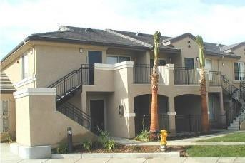5420 Sunny Creek Road Carlsbad, CA 92010

760-602-4242

50-unit complex; studio, one, two & three bedroom units affordable to households earning at or below 80% of the AMI*.

## TAVARUA SENIOR APARTMENTS

3568 Harding Street

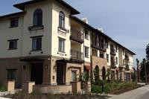Carlsbad, CA 92008

760-730-9281

10 two-bedroom units, 40 one-bedroom units, 10 units are available to households earning at 30% of the AMI, 5 units are available to households earning at 40% of the AMI, 20 units are available to households earning at 50% of the AMI*.

## THE TRADITION

1901 Cassia Road

Carlsbad, CA 92011

760-918-9400

157-unit apartment complex; 24 affordable units, two & three bedroom units affordable to households earning 80% of the AMI*.

## TYLER COURT APARTMENTS

3363 Tyler Street

Carlsbad, CA 92008

760-434-6776

75-unit senior-only complex; one & two bedroom units; 37 units are affordable to households earning at 50% of the AMI; 37-units are affordable to households at 30% of the AMI*.

## VILLA LOMA

6421 Tobria Terrace

Carlsbad, CA 92011

760-929-7555

344-unit complex; one, two, three & four bedroom units affordable to households earning at 50% and 60% of the AMI*.

## VISTA LAS FLORES

6408 Halyard Place

Carlsbad, CA 92011

760-602-0548

28-unit complex; two & three-bedroom units affordable to households earning at 50% and 60% of the AMI*.

## WINDSOR POINTE

3606 Harding Street

Carlsbad, CA 92008

760-273-0061

26-unit complex; Studio, one, two & three-bedroom units affordable to households earning at 25%, 50% and 60% of the AMI* Carlsbad resident and Veteran’s preference.

## WINDSOR POINTE

965 Oak Avenue

Carlsbad, CA 92008

760-273-0061

24-unit complex; Studio, one & two-bedroom units affordable to households earning at 25%, 50% and 60% of the AMI* Carlsbad resident and Veteran’s preference.

*San Diego-Carlsbad MSA Area Median Income Limits (AMI)