Records Department
Training Manual

Last updated: January 3, 2023

TABLE OF CONTENTS:

Register and Morning Check in 2
Register and Evening Checkout 3
Scanning and Attaching 6
Photo Release and Procedures 9
Impound Release 13
Preparing DA Court Run 15
NCIC List 22
Teletypes from Dispatch 27
Locates 28
Certificate of Release 31
Citations Box 32
Background Checks 33
Press Log 35
Mail – Where does it go? 36
Sealings 37
Mail Procedure for Arrest Report Releases 41
Mail Procedure for Crime Report Releases 44
Mail Procedure for Traffic Accident Releases 47
Crossroads TC 49
Coplogic 53
Oversized Vehicle Permits 57
CHP 180s 60

MORNING: SET UP AT THE FRONT DESK:
In the morning, iCashier needs to be accessed and the CAD system.
To access iCashier (the register system)
- Click on the internet: Chrome icon (Chrome is required)
- Sign in to iCashier using web address cashier.carlsbadca.gov
- When logging in with your username and password:
  - Note the username needs to be lower case
  - We keep the green bag up front until city mail comes and then we put that in the blue police bag for the city.
Log into CAD:
- Access CAD by pressing the black toggle (it goes between CAD and iCashier)
- Open CAD
- Hit JOIN
- Click on event entry tab on bottom of screen to create a call.

EVENING: CLOSING DOWN THE FRONT DESK:

iCashiering shuts down at 4:30pm:
- Go into iCashiering and press
- Press continue.
- In upper right corner, press BALANCE.
- It will give you a log, make sure it is balanced.
- If it is cash, you itemize the money accepted that day.
- Press continue.
- Do the same for CREDIT CARDS.
- For checks do the following:
BALANCING CHECKS

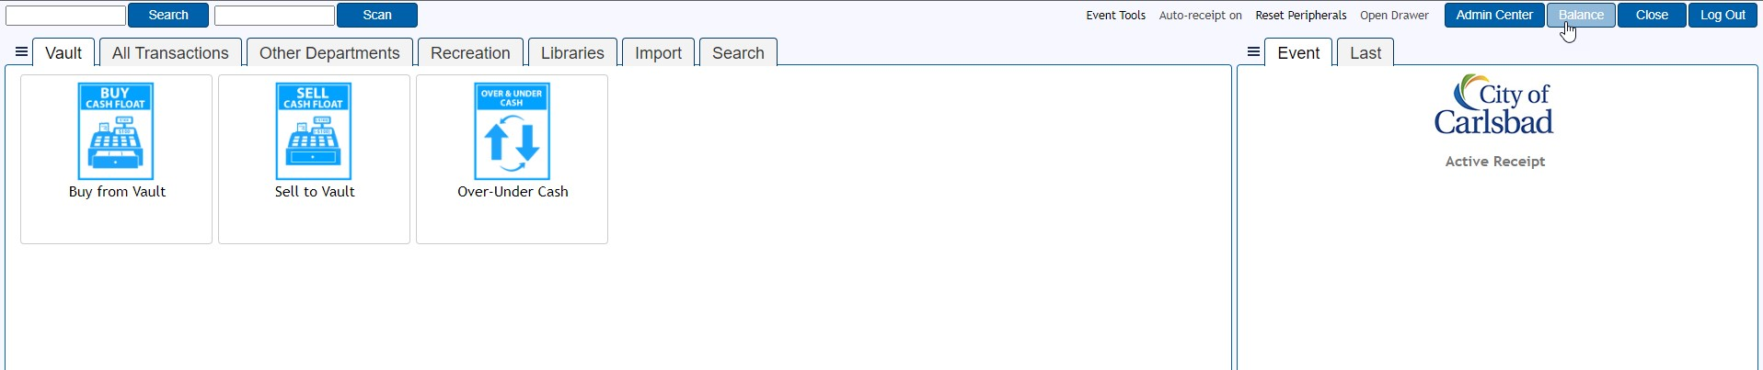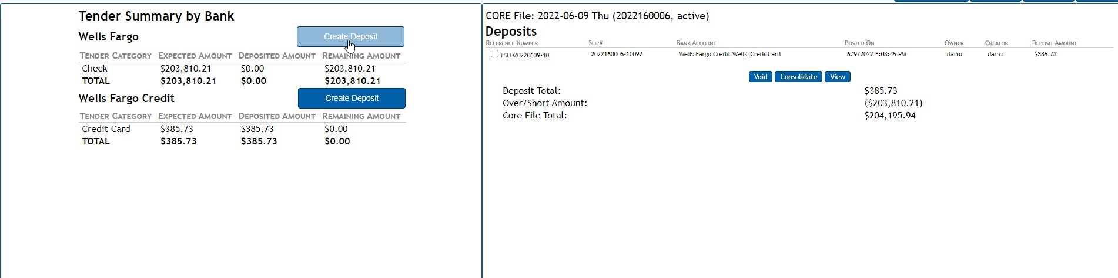
1.

Click the
Balance
tab
in the upper-right corner

2.

Click the
Create Deposit
button

- Collect your checks and add them up with the ten-key adding machine
- Ensure that the calculation is the same as the expected amount
- Enter the amount in the AMOUNT field
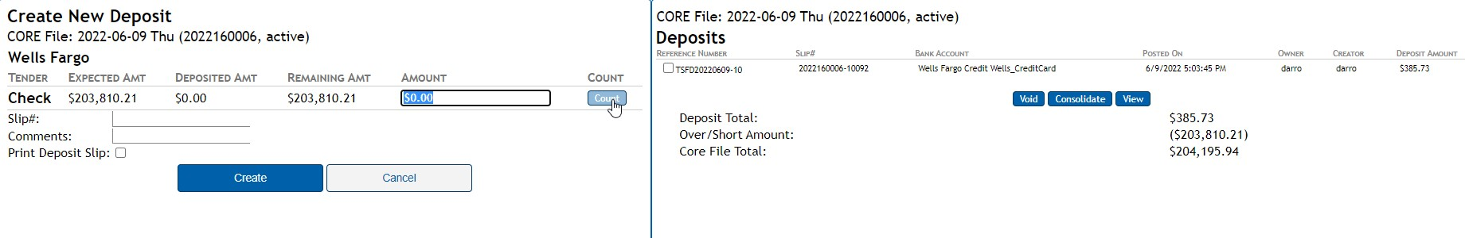
6.

Click the
COUNT
button

7.

Check all of the
Check
boxes

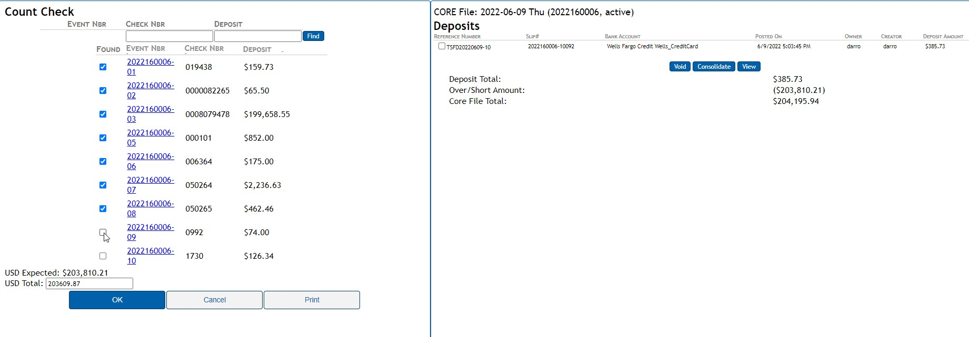

- Click the Print button to create a receipt
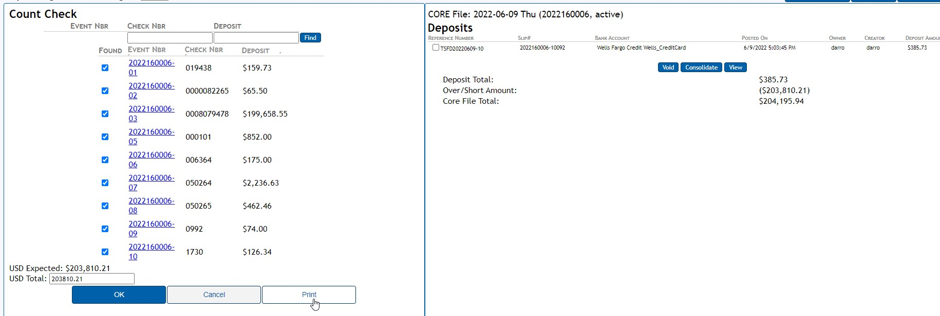

- Bundle all the checks together (EXCLUDING THE CHECK MANUAL CHECKS) with the tickler tape and the Signed Count Check receipt
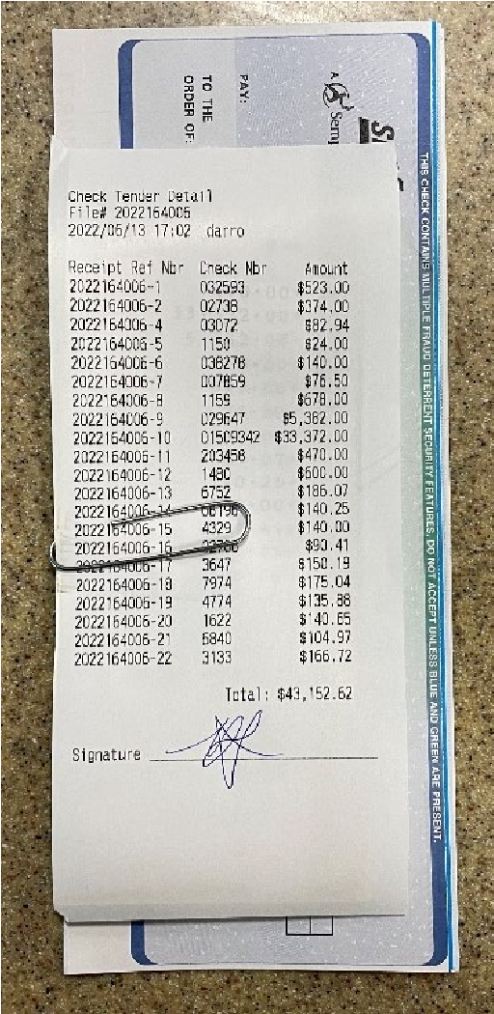
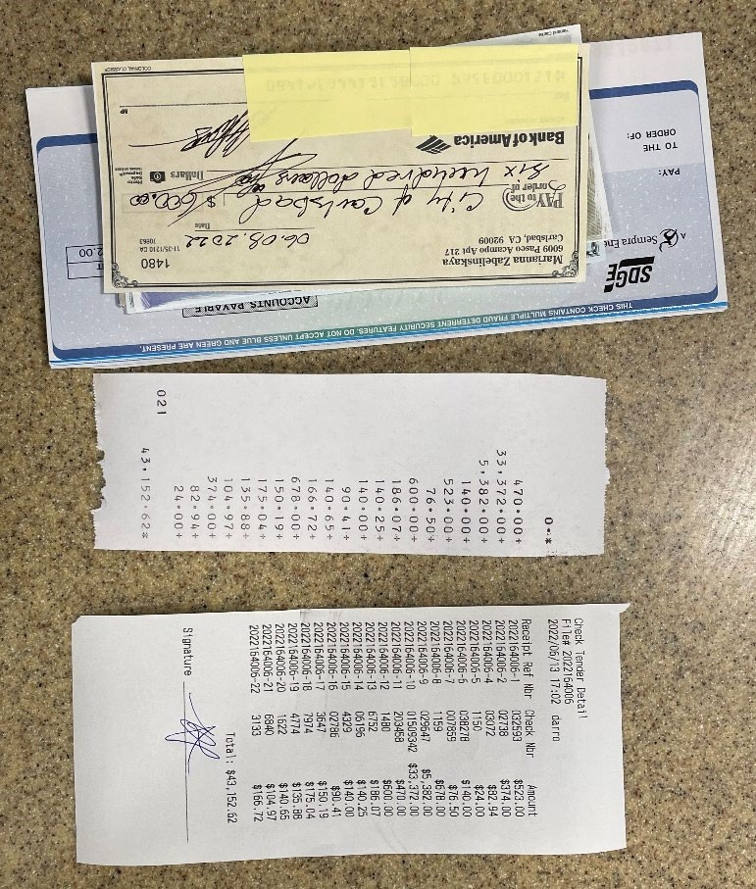
a. Please make sure to sign the receipt →

- Click the OK button
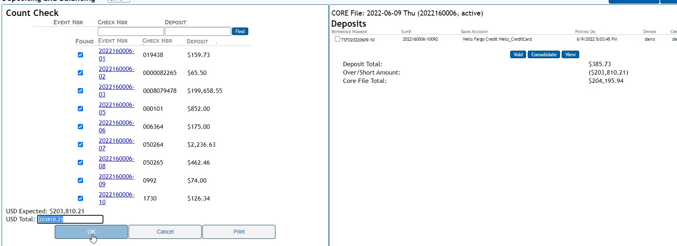

- Please identify the Check Manual checks before sending them to Faraday

- If you are balanced, press continue. It will print receipt.

Log off of CAD:
- At 4:59pm type OPOFF on bottom box and hit enter.
- Click shutdown.
- Turn off computers.

SCANNING & ATTACHING FILES IN NETRMS:
- Retrieve the documents in the bin marked “Attachments.”

- Go through the documents to make sure that they are separated by case number.
  - Verify that each case number is marked in the upper right-hand corner.
  - Make certain not to scan “rap sheets” as per regulations.
  - No need to scan photograph inventories, as they have already been attached and they are simply print outs.

- When scanning, scan each set of documents separately. (This will allow each individual document to be filed in “NetRMS” individually.
  - Scan the document.
  - Send the document to the scan file (drive: I)
  - Very Important - Remember that certain documents need to be handed off to different team members when scanned (i.e. CHP 180’s, Arrest Decs, Juvenile Affidavits, DA Review Requests, Child Protective Service Referrals, Adult Protective Service Referrals, and Admin Per Se’s, Emergency Protective Orders, Gun Violence Restraining Order’s)

- When all the scans have been completed, go back to your desk to name and attach the scans.

- Open the yellow folder that has the computer drives listed. Find the Scans folder under Quick Access. Once opened, you will see the list of scans. Click on the first scan in the list. Name it with the case number first and then name the attachment. For example, 2207991 – Admin Per Se. Continue the same process until all attachments have been named.

- In the left-hand corner of RMS you will find a “? Search.”
  - Search in the “Case Number” field.
  - If the case number is missing or incorrect, you can use the other fields to alternatively search for the appropriate case.
  - A helpful hint is the keep the I Drive open in another window so you can follow along with the scans.
  - Select Finish or press the Enter Key.

- Double click the folder in the yellow rectangle box. Open the case so you can add the attachment to the case folder.
  - If it is a RECORDS related document such as returned mail, report releases or Lexis Nexis, file it under the RECORDS subfolder. If there is not one, create a subfolder.
  - If the document(s) support the case, it goes in the main case folder.

If the case is a new case (in the last year and a half) follow the steps below:

- If the case occurred in the last year and a half or so, you can simply drop the attachment into the “Additional Attachments (DO NOT USE for Evidence)” folder. Click on the link “Additional Attachments (DO NOT USE for Evidence)” and this will open a new window. (It is a folder that is connected to the server.)

- Open the Scans Folder and open RMS in your two screens. From the Scans folder, select the attachment(s). Drag the attachment from the scans folder into case attachment folder.

- Repeat these steps until documents(scans) have been attached.

If the case is an older and does not have the attachment link, follow the steps below.

- When attaching a file, follow the next steps:
  - You need to make sure the case is “Open” to make edits to the folder. Therefore, we will need to change it to open. Follow these steps:
    - Click on “Edit Case Details”
    - Under “Case Status*” move it from the closed status such as Arrest, Department Closed, Submitted to DA etc.) to Open.
    - Click on “Save and Close.” This will allow you to make edits in the electronic file.

- When attaching, determine what type of document it is.
  - If it is a RECORDS related document, file it under the RECORDS subfolder. If there is not one, create a subfolder.
  - All other files are attached in the body of the main folder and in the following manner:
    - Click on “Add attachment.”
    - Name the file.
    - Press “Browse” and attach the correct file.
    - Click on “Finish.”
    - Your file should be appearing as a document in the electronic file.

- Click on “Case Management” to approve the document.
  - Under the action bar, you will see “!” Click on this, then a box will appear. Click on “Finish.”
  - You will see a “check mark.” Click on this, then a box will appear. Click on “Finish.”
  - You will see a “lock” symbol. Click on this, then a box will appear. Click on “Finish.”
  - A Red unlocked lock should appear. This signals that you have successfully completed the step of verifying it.

- You will now need to return the file back to the status that it was when you first opened the case (i.e., arrested, suspended, closed by department, etc.)
  - Click on “Case Details.”
    - Move the section to the desired field. Then, click on “Save and Close.”

- You will need to do this individually for every individual scanned file.
- Alternatively, if the case is a newer case, you can simply drop the attachment into “Additional Attachments (DO NOT USE for Evidence)” folder.

- Click on the folder by clicking on “Additional Attachments (DO NOT USE for Evidence)” and this will open a new window. (It is a folder that is connected to the server.) Drop the attachment from the scanning folder into this folder. Rename and close out of the window that popped up

PHOTO RELEASES AND PROCEDURE:
Who to release to: Victim of crime, Driver(s) in TC, passenger(s) in TC, registered owner(s) of vehicles involved in TC, insurance company, law firm with client waiver.

Where to find Photos: Quetel

What to release: Per evidence code 1040(b)(2): redact any photos that are graphic or contain dead or dismembered bodies.

Quetel Steps for Photos on CD:

Step 1: Open Quetel
Step 2: Login, username is “cb____”
Step 3: In the top left hand corner select then select
Step 4: Select
Step 5: On the “Query Selection” screen, select “Case Search(Global)” (it will become highlighted in orange)
Step 6: On the right hand side select “Run Selected Query”
Step 7: Enter in the case number with the hyphen, ex) 20-01635
Step 8: Select “OK”
Step 9: Select
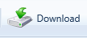
Step 10: Select the photos/videos you are releasing
Step 11: Select
Step 12: Enter the reason for downloading the photos, ex) records request from law firm
Step 13: A box will pop up at the bottom of the screen asking what you want to do with the downloaded file. Select to save as. Save file in a spot where you will remember where it is located.
Step 14: A box will pop up at the bottom of the screen once the file has been saved. Select
Step 15: Open the “zip” file
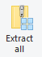
Step 16: Select all the images/videos in the zip file
Step 17: In the top right of the screen select
Step 18: Save the extracted files in a spot where you will remember where they are located. Select extract.
Step 19: Delete the zip file
Step 20: Review the downloaded photos/videos and delete any that are not releasable(if applicable)
Step 21: Open the CDBurnerXP application
Step 22: Select Data disc, select “Ok”
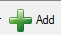
Step 23: On the left-hand side, find where you saved your files
Step 24: Select all the files and select . The files will now appear in the bottom portion of the application
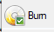
Step 25: Insert a CD into the CD burner in your computer
Step 26: Select
Step 27: Select “Prevent further changes to the disk (finalize)”
Step 28: Select “Bun disc”
Step 29: Once the media is burned onto the CD, write the case number on it.
Step 30: Finish the request by either calling the requestor for pickup or mailing the media to the law firm or insurance company.

Quetel Steps for Printed Photos:
Step 1: Open Quetel
Step 2: Login, username is “cb____”
Step 3: In the top left-hand corner select then select
Step 4: Select
Step 5: On the “Query Selection” screen, select “Case Search(Global)” (it will become highlighted in orange)
Step 6: On the right-hand side select “Run Selected Query”
Step 7: Enter in the case number with the hyphen, ex) 20-01635
Step 8: Select “OK”
Step 9: Select
Step 10: Select the photos/videos you are releasing
Step 11: Select
Step 12: Enter the reason for downloading the photos, ex) records request from law firm
Step 13: A box will pop up at the bottom of the screen asking what you want to do with the downloaded file. Select to save as. Save file in a spot where you will remember where it is located.
Step 14: A box will pop up at the bottom of the screen once the file has been saved. Select
Step 15: Open the “zip” file
Step 16: Select all the images/videos in the zip file
Step 17: In the top right of the screen select
Step 18: Save the extracted files in a spot where you will remember where they are located. Select extract.
Step 19: Delete the zip file
Step 20: Review the downloaded photos/videos and delete any that are not releasable(if applicable)
Step 21: Select all the photos you are printing
Step 22: At the top right hand of the window, select
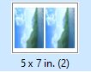
Step 23: Select
Step 24: On the right-hand side select
Step 25: Ensure that the “Police-Records2” printer is selected so the photos will print in color
Step 26: Select “Print”
Step 27: Finish the request by either calling the requestor for pickup or mailing the media to the law firm or insurance company.

IMPOUND RELEASE:
A. If car was towed for registration:
      - Verify they are the registered owner (“R/O”) Only registered owner can get a car release.
      - Must have a valid driver’s license.
      - Must have paid/cleared car registration or one day moving permit issued by the DMV.
To do this, login to SDLAW and eSun webpage:
- Go to blue multiple tab and click on driver’s license/vehicle inquiry.
- Insert license plate number and driver’s license number.
- Submit inquiry.
- Go to messages and print all three.
The teletypes will show:
- If driver’s license is valid.
- R/O of the vehicle
- Location of car towed.
Fill out impound release form and make R/O sign it:
- Make two copies of impound release form with driver’s license on the bottom and printed in color.
- Make copy of registration/moving permit.
- Take payment of $125.
- Provide one copy of impound release form to person and give back their driver’s license and registration.
- One copy of impound release, teletypes, and copy of their registration/moving permit is ours and must go in attachment bin.
If car was towed for no driver’s license:
- R/O must be present.
- Driver with a valid driver’s license must be present. This is who the tow yard will release the vehicle to.
Login to SDLAW and eSUN webpage:
- Go to blue multiple tab and click on driver’s license/vehicle inquiry.
- Insert license plate number and driver’s license number.
- Submit inquiry.
- Go to messages and print all three.
The teletypes will show:
- If driver’s license is valid.
- R/O of the vehicle
- Location of car towed.
Fill out impound release form and make R/O sign it:
- Make two copies of impound release form with driver’s license on the bottom and printed in color.
- Make copy of registration/moving permit.
- Take payment of $125.
- Provide one copy of impound release form to person and give back their driver’s license and registration.
- One copy of impound release, teletypes, and copy of their registration/moving permit is ours and must go in attachment bin.

PREPARING DA COURT RUN:
AM Priority/Jail Log: Look who is in custody (process first), sort by appearance date.
Jail Report:
- Click on “click here to continue.”
- All PD’s at top of list.
- Open- click on day you want- top is previous day (make sure effective date in the upper right-hand corner) is correct.
- Click on CBPD at left column – print CPD only in landscape – current page (For example, on a Monday you run, Friday, Saturday and Sunday.)
  - Fax to United Reporting (programmed on Fax)
  - Two -hole punch and place in lobby
“Booking Photo”
- SDLaw
- EJims
- Inmate Query
Reason: “CBPD Records”
If you have a booking number use it, otherwise use first name and last name (copy CII#)
Personal/print PDF
Copy CII# to use criminal history
Criminal History/Rap Sheet: Never fax or attach a criminal history.
- By name or record # A ---, copy all but not letter.
  - SDLaw
  - ESun Web
  - State
  - Criminal History
  - Name Inquiry
  - Reason: Case #

- By CII #
  - 1st one CH Transcript (Rap Sheet)
  - Reason: DA Case #
  - Paste CII# top one Rap Sheet
- Submit.
- Print Message.
A warrant arrest (unless additional charges) or 647 (f) book and release report does not need to go on the court run unless there are additional charges. (Try to determine case assignment – most warrants go to the COV sergeant.)

Approving Arrest Reports
TWO types of arrest: (If not sure, open report and check to see if report as arrest = report type*)
- Cite Arrest – arrest with citation with promise to appear
  - Offender
    - JUS 750 Type* - 1 – Cited
    - Citation #
      - If citation is for a SUSPENDED LICENSE (1461.1): print out CAD call teletype from Tiburon and print persons info, stamp with large CLETS stamp, send to court. (Citation should be written to go to North County Division.) Infractions, municipal codes send to annex – citation only
      - Cite Arrest: ADD Notes in CASE LOG for Cites Arrest “All reports, attachments, criminal history, and original cite sent to the DA on 09/09/2020 court run.”
  - Arrest – booking into jail
    - Offender (CHECK AGE) add booking #, from below booking photo. (If cite arrest no booking # you add CITE number)
      - 5150 Arrest
        - Offender
          - Check age (Adult – COV/Sgt, Juvi – Family Service/Sgt)
          - No booking #
        - JUS 750 Type * -3- Other
        - LE Disposition – 1 – 849(b)(5) Mental/Medical Transport
        - Released Location - Which hospital, if not listed, check narrative.
    - Offense
      - Verify the offense, check for multiple offenses, change subject line to reflect.
      - Look for * Complete – yes
      - Hate/bios – no (if yes, read the narrative.)
      - Domestic Violence – No (unless DV)
      - Always be aware an check list to see offense is listed on Victim’s Assistance. If so, make a copy and stamp with confidential stamp and write sent to VAP and put in Victim Assistance Tray by copier.
      - Recovered Stolen/Stolen vehicle report fax to RATT.
      - If crime is a felony print a SOC, if witnesses print a witness list.
      - If DUI, check narrative to see why suspect was pulled over to determine if a TC needs to be included. Also add the Traffic CSO in “edit case assignment” to review the TC DUI’s for billing.
      - Offender
        - Check age
        - Make sure to enter in booking # (located under booking photo on eJims)
        - If a juvenile needs a Juvi Affidavit to send via mail to Juv DA. Send Juvi Affidavit, Intake Screener and Report to:
          - Attention: Issuing
Juvenile District Attorney
2851 Meadowlark Drive
San Diego, CA 92123
        - Cite Arrest: Notes in CASE LOG for Cites Arrest “All reports, attachments, criminal history and original arrest dec sent to the DA on 10/30/2020 court run.”
Property: Drug paraphernalia, Status: Evidence
Drugs, Status: (6) Seized
  - Order of Pile when sending to court:
    - eJims/Booking Photo or Original Cite (if cite arrest) OR original arrest dec
    - Juris/SOC (if “F” if someone has a felony (F): print SOC- Arrest Report)
    - Witness List
    - All reports (Dot reports and officers reports)
    - All attachments (If DV supplemental, DV resources, all property & evidence, don’t need CAD or booking sheet) (DUI Needs Admin Per Se and TC if applicable)
    - Criminal history/Record (Never fax criminal history. If no criminal record- PRINT and write “no match”.)
    - Staple and put in Court run

Processing Arrest Dec: “Superior Court of California…. Declaration in Support of Arrest Warrant” Scan and put in processing bin.
      - When processing: Send in court run: Case notes for Arrest Decs: Original Dec with blue signature, crime report, all attachments, criminal history sent to the DA on 09/10/2020 court run.”
Processing Admin Per Se (DUI): Original with copy of report and TC if applicable and original license goes to DMV, along with blood alcohol reports and DMV record from CAD. Court gets a copy of the Admin Per Se with file in the run. We keep the yellow copy for our file. (Stamp with DMV, Attn: Admin Per Se, Mail to DMV)

Canceling a Case Number in RMS

- Ask officer to cancel case number with Dispatch
- Verify in CAD the case number has been canceled. There will be a (C) next to the case number which indicates the case number has been canceled.
- DO NOT ADD A RECORDS SUBFOLDER
- There shouldn’t be any reports or attachments in the case.
- Go to Edit Case Details
- The Fields highlighted below should be as follows:
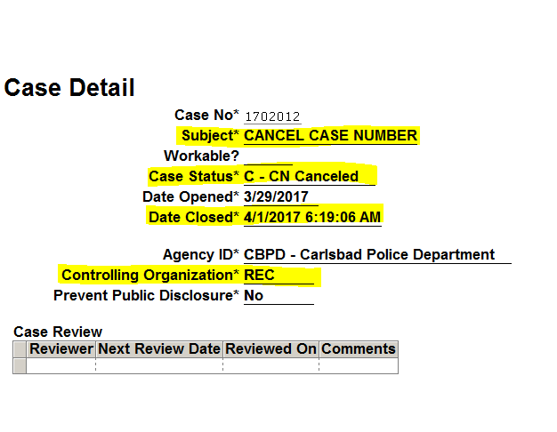
- Save and Close
- Got to Edit Case Assignment
- Remove all assigned Officers
- Go to Change Controlling Organization, Records should be highlighted in blue, Select All, and click on Finish.

Missing Reports in RMS
- Select Case Management
- Select Case Workload
- Under FO, select each category (D1, D2, E1, E2 TRF) to review cases
- Look for cases that are old, in-progress, attachments that need to be approved all the way through, cases that need to be closed out (CHP180’s).

Case Purging
- We purge cases that are 10 years and older however there are some we keep.
- The cases we keep are felony arrests (Homicide, Rape, Robbery, Assaults(aggravated then simple), Burglary, Larceny Thefts, Auto Theft, and Arson), all sex crimes, child abuse crimes, missing persons, stolen vehicles , stolen plates and stolen guns.
- Grab a box of cases to purge.
- Open RMS and search the case number from the top of your stack of folders.
- Open the RMS file folder and take out the documents from the paper file
- Make sure all the attachments and reports are in Laserfishe or RMS file.
- Purge all documents
- Recycle or discard file jacket.

Attachment Purging
- We hold on to paper attachments (documents in the file folder) for 3 years. We purge attachments that are 3 years and older.
- Grab a stack of folders from the rack and take them to your desk.
- Open RMS and search the case number from the top of your stack of attachments.
- Open the RMS file folder and take out the documents from the paper file
- Make sure all documents in the file folder are scanned into the RMS File. If they are all attached, they can be purged.
- If they are not electronically scanned into the case, write the case number on the top right and put in the scan tray.
- Repeat until all folders have been checked.

Citation Purging
- Parking Violations and Notice to Appear Citations are kept for three years.
- Both types are filed numerically.
- Go through each type of citation (Parking and Notice to Appear) and purge any that are 3 years and older.
- Shred the old citations.

Ebike Citation Procedures

- Look through eCites and regular cites for any ebike violations.
- Send them to (Deputy City Attorney overseeing Policy and Leadership) for Review in interoffice mail. The Deputy City Attorney will send them back to Records. Look for any notes from her such as rejections or corrections. Handle accordingly.
- Save the citation for 10 days from the date of violation.
- The Senior Program Manager in charge of the Juvenile Justice Program will send Records the list of arrestee’s (Adult and Juvenile) who have signed up for the class* and the cites we need to set aside. The cites can be found in Records filing cabinet.
- After 10 days, enter adult cites into ARJIS for people who have not signed up for the class and send Adult Citations to court.
- If the arrestee completes the class, Senior Program Manager in charge of the Juvenile Justice Program will notify us. Pull cite from folder in Records filing cabinet and file on the cite wall. If it is an eCite, you can shred the original because it is still available in CCM. If the arrestee does not complete the class, the Senior Program Manager in charge of the Juvenile Justice Program will notify us. Give citation back to officer to complete the cite correction and change the appearance date to a later date and time. After we receive the correction back from the officer, complete citation proof of service on the back of the form. Make two copies. Send one copy to the arrestee, file one copy on the citation wall or the in the eCites correction folder. Enter the original cite into ARJIS and send to court.

*Bike/ebike Safety Course Registration is located on the City of Carlsbad Police Department’s website. Class is open to adults and juveniles who have received the Muni Cite violation 10.56.020 (C)(1).

NCIC List:
Consists of Stolen boats, vehicles, lost or stolen plates, missing persons, and stolen handguns. (We receive the form from Records Manager.)
  - Go into NetRMS and print report.
  - Go into SDLaw and make verify entered as stolen.
  - Go into Records folder- NCIC.
  - Create and mail letters.
  - Write on form from Records Manager “letters mailed.”
Approving Reports: Use SVS Property book from cabinet

Stolen property Entry/SDLaw for Serialized stolen property
Copy the property and front page of the report (easier to print whole report)

SDLaw (OCA# = Case #) Example #1
- ESunWeb
- State
- Property
- Single Record Entry (Property binder)
  - Date
  - Case #
  - Serial Number (From Report)
  - Brand (State that is from or name brand/manufacturer- refer to back of binder
  - Category (single letter/far right column, refer to binder)
  - Article code (partial word/center column, refer to binder)
  - Date of transaction: date occurred from report (year/month/date)
  - Document code: on report under status
  - Model #: if there is one.. ex: iPhone 11
  - Miscellaneous info: more detailed description
- Print and paper clip together, stamp with
ENTERED BY_____
CHECKED BY_____
- Give to a coworker to check
License Plates:
- Run plate – California vehicle inquiry. If “sub-plated” do nothing. If not “sub-plated,” follow procedure for stolen vehicles/boats… use license plate letter.
Missing/Recovered JUVI or Stolen/Recovered Vehicles must have teletypes to verify missing etc. If not, retrieve from Tiburon CAD Call
Missing Persons/Unidentified Persons
- Run person in ESun – missing person name inquiry. Verify information is correct. (Make corrections if necessary. (Remove returned persons.) If missing, print out copy and send to investigations with eSun entry information. Check box on printout and date sent to investigations.
  - SDLaw
  - State
  - FCN# (If it doesn’t come up in RMS)
  - Missing person/name inquiry)
  - Print
Missing Persons/JUVI Locate
- NetRMS: Add a case report (.2), Report Type: Missing Person Report, Report Created On, Report Created By, bring forward from case, click on victim-missing person report type (REPORT TYPE must be missing person, whether or not lost or found, if not reject report. Reason for returning-
“Please change your crime report type to ‘missing person.’ This will allow you to show Juvi as found. -Victim found, narrative: “Received a teletype from SDSO/? Notifying CP that they have located our missing juvenile, (name). Missing person has been removed from MPS by dispatch. See attached teletypes.”
Auto Locate: Add case report (.2), pull forward, Report Type: Follow Up Report, Property (pull forward vehicle) date and time recovered (take from locate), change property to jurisdiction stolen and recovered, status: stolen and recovered: recovered from other jurisdictions 099, add narrative include case #, include damage/plates or any info from teletype.

NETRMS: Processing
Approving reports, four choices:
- Error Check (if there is not error check icon we cannot approve, will need to reject it back to the officer)
- Final approval of report
- Rejection back to officer
- Will open up case… do not use!
Different Stages of Report Writing:
- In Progress Status: Officer has opened up a case report and is in the process of writing it.
- Submitted Status: Report is waiting for Sergeant Review and submit to records.
- Verified Status: Sergeant has reviewed case and submitted it to Records.
- Approved status: Records has reviewed case and approved it. Approved reports cannot be unapproved to make corrections. A dot 2 report must be written to correct errors.
The first report must be a case report, a dot report. If the Officer is documenting an incident report, it should be an I/R with the offense code of 981000 ZZ.
Courtesy Reports:
- Subject Line – Courtesy Report
  - Unknown address is 00 = Unknown, City = Unknown
  - Jurisdiction = 099
  - Victim Tab – The victim is a victim at Courtesy Report
Review: Victim, witness, property, narrative (only read for clarification). We do not use Case Summary or Evidence Summary, but we do not use Case Log. (Case Logs cannot be deleted or modified.)
Always approve reports in order… dot 1, dot 2, etc.
Officer’s Reports cannot be changed, make sure it doesn’t include “new” people. If so, a new dot report will need to be written.
The Bucket:
Screen 1/ “The Bucket” ON RIGHT
Lobby
- Records/Case Admin
- Case Reports Pending Approval
- #CR’s pending approval (verified): we can only approve verified reports. We cannot verify, or process reports done by a sergeant.)
- By date
- View all
- Enter Case # on left screen
To refresh, Push any button on screen, F5.
Screen 2/ Normal RMS Screen-Case Files-Search- Case #, open case, case management
Crime Reports Only/Arrest Reports Additional Notes (See Below)
- Open Case
- Case Management
- Click Error Check icon- no errors- close.
- Open/Review Report
  - Subject Line:
    - Location: Make sure it is a Carlsbad address. If not a Carlsbad address/Courtesy Report/Beat 099. Make sure the report was not a lobby call with a 2560 Orion address. If so, return to the officer to correct the incident report.
    - Line Order: Report type – IR = Incident Report, CR = Crime Report, AR = Arrest Report. Violation Type/Code – VC or PC, Code, Check offense tab. Name – V -, or S- (victim or suspect) Example: CR – PC **** - V/Smith, AR -PC **** - A/Smith, IR -13730 – Name – DV Incident / 13740 – There should be no suspect or victim entered. Persons should be listed in others tab. COPY SUBJECT TO PASTE LATER.
  - Subject
    - Always check the age to determine if it is a minor and would need to be assigned to Family Services Sergeant.
  - Offense
    - Verify the offense, check for multiple offenses, change subject line to reflect.
      - Look for * complete – Yes
      - Hate/Bios – No (If yes, read the narrative)
      - Domestic Violence – No (unless DV)
      - Lots and Found Property, there will be no offender, victim, or witness. If victim or offender, open and delete.
      - Always be aware and check list to see offense is listed on Victim’s Assistance. If so, make a copy and stamp with confidential stamp and write sent to VAP and put it in Victim’s Assistance Tray by copier.
      - Recovered Stolen/Stolen Vehicle Report Fax to RATT
  - Offender:
    - Check Age
To approve- … click on the lock icon to approve
  - Lost/Stolen/Recovered license plates verify teletypes before approving.
  - 10851 – stolen and/or recovered vehicles verify teletypes before approving.
  - Missing persons verify teletypes before approving.
    - Return to case:
    - Add a “records” subfolder
    - Edit case details: paste copied subject line
    - Edit case assignment
      - Remove officer (Shift? – for date and time)
      - Add sergeant
        - Property: (vandalism, found property, theft)
        - Family: (Juvi, Elder abuse, DV, missing or found Juvis, school incidents, 5150 Juvis)
        - COV: (missing adults, violent crimes, rape, guns, death, warrants, 5150 arrests)
        - VNU: (647Fs, drugs, gangs, dui)
        - CST: (20002/Hit and run assign to Accident Investigators and Traffic Sergeant)
        - Case assignment type/ Assisting Detective
        - Done- Cancel Out
      - Case Management
      - Change Controlling Organization
        - Select All
        - Finish
After completing, get back to the home screen by clicking on lobby (top left, grayed bar)
- Approving TCs: Add the Traffic CSO as “assisting Deputy” to all, don’t add a sergeant. Print before approving (TCs don’ have an “error” button to check the report, this is why you print, so that you can check it_ always print diagram too if there is one.
**Once a report is approved, it should never be unapproved. We can never delete “.” Reports.

Teletypes from Dispatch:
When you pick up teletypes from dispatch:
      - PPI or REPO: Inside drawer
      - Patrol Roster: Hole punch. Put on Patrol Roster clipboard
      - Cancelled case: Goes to processor
      - 290, Arson, Sex Registrants: Goes to Faye
      - Stolen License Plates: Write Case #
      - Locate teletypes: Scan, give to person doing locates
      - Missing person cancel: Scan, make sure Faye wrote report be checking RMS. Give to processor.
      - Missing person locate from other agency: this means that our missing person was located by another agency so we can scan teletypes and give to whoever is doing locates.
      - Missing person teletypes: if we receive teletypes of another missing person but located by us, we just scan. Officer writes the report.
      - Restraining order teletype: write case # on top. Scan.
      - Criminal history “restricted. Do not use for employment licensing”: Shred. We can’t keep criminal history.
      - Livescan transaction agency info: Write case # on top. Scan.

Locates:

Teletypes of located person will come from dispatch.
Log into NetRMS:
- Look for case number in teletypes and type into NetRMS
- Once you find the case, the status must be OPEN
- Click on “Add Case Report” on left hand side
Once case report opens, it will be .2 or a .3 and fill in:
- Report Type *: Missing Person Report
- Report Created by*: CB60__
- Case disposition*: 5 inactive
Go to victim tab:
- “Click here to bring forward a victim” at the bottom of the screen
- Click on “Bring forward from case”
- Click on the missing person’s name (usually V1)
- Go down to missing person report type*: Found
Go to narrative:
- Look at teletypes for time and date that the agency sent the notification of the missing person
- Type in “Received locate notification on October 31, 2020 at 0433 hours from San Diego Police Department. Subject was removed from MPS (add this when teletypes say MPS Cancel)”
- Save and close
Click on the computer with red check mark icon next to your report to “check for errors.” Click on the ! then finish.
- Go to case management on left hand side
- Click on change controlling organization
- Checkmark your report
- Choose the organization: click whoever is on shift at that time, ex. D1 or D2)
- Click and finish
Scan and attach.

Teletypes of a located vehicle will come from dispatch.
Log into NetRMS:
- Look for case number in teletypes and type into NetRMS
- Once you find the case, the status must be OPEN
- Click on “Add Case Report” on left hand side
Once case report opens, it will be .2 or a .3 and fill in:
- Report Type *: Follow Up Report
- Report Created by*: CB60__
- Case disposition*: 5 inactive
Go to victim tab:
- “Click here to bring forward a victim” at the bottom of the screen
- Click on “Bring forward from case”
Go to property tab:
- “Click here to bring forward property” at the bottom of the screen
- Click on “Bring forward from case”
- Choose the vehicle and click on finish
- On the property field change the status from “Locally stolen” to “stolen locally and recovered by other jurisdiction”
- Change the stats from “stolen” to “both stolen and recovered”
- Look at the teletypes for time and date that the agency recovered the stolen vehicle
- Under the Vehicle Damage section fill in the location towed/recovered from, and CSZ Towed/Recovered from. This information is found in the teletypes.
Go to narrative:
- Look at teletypes for time and date that the agency sent the notification of the recovery
- Type in “Received locate notification on (date) at (time) hours from (agency).
- Look at the teletypes for information about the condition of the vehicle “Vehicle damaged/not stripped. No plates are missing. No one in custody.” Add any other relevant information to the narrative from the teletypes.
- Save and close
Click on the computer with red check mark icon next to your report to “check for errors.” Click on the ! then finish.
- Go to case management on left hand side
- Click on change controlling organization
- Checkmark your report
- Choose the organization: click whoever is on shift at that time, ex. D1 or D2)
- Click and finish

Ensure victim/registered owner of the vehicle has been notified of the recovery. This information can be found in CAD or on the face sheet of the teletypes. If the victim/registered owner of the vehicle has not been notified you need to contact them either by telephone or mailing a notice of stored vehicle.
Request report from the agency who recovered the vehicle.
Scan and attach.

Sheriff’s Department: Certificate of Release:

Go to NetRMS and insert case number. Case status must be open and .1 must be approved. If it is not open, open and leave it as it is. Click on ADD CASE REPORT on left hand side.

Under administrative tab insert:
- Report Type*: A- Arrest Juvenile Contact
- Report created by *CB60__
- Case Disposition*: 2- Arrest
Offenders Tab:
- Click on “click here to bring forward an arrestee” at the bottom of the screen
- Bring forward from case
- Click on the person
- LE Disposition8: 849.5 Released (No charges filed)
Narrative:
- “Processed Detention Certificate. DA did not press charges.”
- Save and close
- Check for error by clicking the computer with red checkmark on it.
- Click on ! submit finish.
Case Management:
- Change controlling organization
- Checkmark report you just wrote (usually a .2)
- Choose the organization to whoever is on shift ex. D1 or D2
- Finish
Scan and attach.

Citations Box:
Separate into piles…
- Is there a case #
- Age (checking DOB to see if minor)
- Code (CVC or Muni)
Types of citations you may see:
- Yellow/Stapled (completed) citation books: get filed numerically in the last row, at the end
- Pink/Stapled (completed) citation books: get filed numerically in the wooden shelves on the wall
- Juvenile citations: send original citation and small juvenile slip of paper to the Senior Program Manager in charge of the Juvenile Justice Program, put in “detective” tray by the copy machine
- Citations with corrections: once corrections are made… sign and put address and date on back. Make two copies (send original to court, mail one to the defendant, and file ours in drawer by copier)
- CVC/VC Citations (No Case #) put in “traffic/minor offense” mailbox by the copier
- Drivers License (with or without a DMV- 310/Notification of suspended license) place in hanging DMV envelope by file cabinet
- Parking violations: put in “traffic department” mailbox by copier
- Muni Codes (enter into Arjis.. see example)
  - Data forms
  - Citations
    - Type MC, Court Code NC (when completed initial and date at bottom right of cite and put in envelope and send to the city attorney)
    - 62.669 SDCC (dog on beach) – enter into Arjis as MC 11.32.030 (court code NV)
    - If transient enter address # as 0 and street as transient
- Citations with Case #s
  - Scan citations with case #s
    - If citation is for a suspended license (14601.1): print out CAD call teleype from Tiburon and print persons info, stamp with large CLETS stamp, send to court. Unassign, change controlling org/records and department close. (Do not need to send report.) Notes in case log for cites: “Original citation and CAD sent to court in court run on 09/19/2020.”
    - If citation is for a traffic violation/ Annex, not a crime, place in the cite tray
    - If citation is a crime, place in processing tray
- Warnings:
  - Place in pile to be entered into Arjis

BACKGROUND CHECKS:

Background checks must have Notarized Released form attached to it. We need two stamps: “No Record Carlsbad Police Department” with signature and date, as well as a “Carlsbad Police Department” stamp.
We only report adult arrests from Carlsbad PD. No juvenile reports. No citations. We check three different systems to double check that person has no record.

ARJIS:
- Go to applications EQuery (MOI11)
  - Reason: background check request
  - AGCY: Carlsbad
  - Last, First, DOB Submit
  - DOB Submit (scroll down to see if any names match the person)
SDLaw:
- Go to eJIMS Query
  - Reason: “Background check request”
  - Last, First, DOB
SDLaw:
- Go to eSUN Web County DA Name and Case Search (DA09)
  - Last name, first, DOB (year, month, day ex 19921002)
If no record found:
- Stamp front of Background Check Request with the two stamps. Sign and date.
- We only stamp. We will never fill out any form.
- Fax or mail back: we NEVER email.
To fax:
- Fax records fillable: date, time, attention, department, fax #
- Message: attached is the background check per your request
- Put in fax machine tray. Punch in fax # with 1 first ex. 17609290243
- Hit start then leave on top of machine for fax confirmation.
- Staple and file when confirmation comes in. File inside drawer.
To mail:
- Make a copy for records
- Stamp copy with “mailed” stamp with today’s date and initials
- Store inside drawer
- Original copy gets mailed
If record is found:
- It must be a Carlsbad Police arrest
- Look for case # in NetRMS or files in the back
- Agency gets a copy of report. Make a copy for records
- Stamp “confidential” on all pages
- Fax or mail arrest report with attached background check request

PRESS LOG:

- Log into Tiburon with your CB####
- Go to the system box and click on it
- Drop down box Crystal Reports Catalog
- Scroll to Press Log
- Create date range desired and run report
- Export PDF for printing
- Print
- Redact Press Report- Names, minors names, phone numbers, apartment numbers

MAIL: WHERE DOES IT GO?:

When US mail comes, sort and open envelopes for Records Department.
Once you open, if it is a:
- Background check: to person assigned to backgrounds. Must have notarized stamp
- Notice of release: Senior Crime Analyst and Professional Standards Sergeant
- Notice of hearings: Senior Crime Analyst and Professional Standards Sergeant
- Courtesy Reports from other agencies: put sticky note, write “Case?” send up to investigations
- Sealings: person assigned to sealings in records
- Trespass arrest: dispatch
- CHP 180s returned: make copy of envelope and all three attachments go to the attachment tray
- Parking Cites: put in traffic tray inside our office
- 911 Audio/CAD Request: Sign and date at the bottom and make a copy. Copy goes inside green folder and original goes to dispatch.
- Citation returns: Officer’s box
- Juvenile affidavit: Scan and send to investigations
- Notice and Instruction to Arresting Officer: Put in Officer’s box
- Accounts payable: Admin tray
- Purchaser prohibited do no release firearm: Property and evidence
- Disposition of arrest and court action: property and evidence
- DMV Subpoenas: stamp the one that has the envelope with “agency” stamp. Put in traffic tray
- Locates “Notice of vehicle locate”: goes to person assigned in Records
- Felony notification to Sheriff “notice to pursuant to welfare and institution code”: Look for case number in ARJIS or eJIMS. Then goes in the attachment tray
- U-VISA “U non-immigrant status certification”: goes to Special Investigations Lieutenant.

SEALINGS:

Juvenile Record Seal Checklist: NetRMS

Each petitioner should have an individual checklist, which should be placed in the sealing envelope when procedure is completed.

- Search name in MOI11:

_____ If no record is found, STOP HERE and send a “Juvenile Seal No Record” letter along with the court order. Example A.

_____ Print out screen to use as a guide. Place in envelope when done.

2. Send the letter of sealing notification:

_____ To Juvenile Division. Memo example B.

_____ To outside divisions/agencies that received a copy of the report. Letter example C.

3. Notify Property and Evidence:

_____ Copy Memo example B and forward to Property/Evidence.

4. Prepare large envelope:

_____ Place petitioner’s name (last, first) and the Case number on top left-hand corner of envelope.

_____ Put corresponding label on center of envelope.

5. In ARJIS:

_____ Delete records from ARJIS. If original cites are not found, print out copies of cites to place in envelope before deleting. Only delete suspect/arrest reference to subject of sealing. If it is a crime report, do not delete victim/crime screen.

6. Prepping case for sealing for ONE arrestee:

_____ Print an original copy of entire case (including attachments and records folder) for the sealing envelope.

_____ Change Case Status to Open.

_____ Un-approve all attachments and delete from case, including the records folder.

_____ Un-approve report for redactions, beginning with the last report.
_____ On the Admin tab, remove name of person being sealed from subject line (if applicable).

_____ Open up a Word document and copy report narrative.

_____ Within the narrative, replace arrested subjects name with A1 throughout the narrative.

_____ Copy redacted narrative back into RMS report.

_____ Save and close redacted RMS report.

_____ Approve case report.

_____ Select SEAL Individual Tab on the bottom left-hand side. Select the name of subject to be sealed and select the add button. You will see the name of the subject to be sealed move to the
box below. Select the Seal button.

_____ Prepare a Juvenile Seal Purge (Example D). Scan and attach to RMS. Put original notice in file folder, if applicable.
_____ Go to Edit Case Detail:

SUBJECT………………………………………type- “Court Ordered Sealing”
CASE STATUS………………………………...status at beginning of sealing, i.e. Arrest or Submitted DA
DATE CLOSED………………………………..current date/time
CONTROLLING ORGANIZATION………...Records
PREVENT PUBLIC DISCLOSURE…………Yes
WHY EXCLUDED…………………………….type-O, see primary Det/Supervisor
UPON ORDER OF…………………………….Records Manager
DATE/TIME ORDERED……………………...current date/time

7. Reponses from Juvenile Division and Property/Evidence:

_____ Add any responses from Juvenile Division into envelope.

_____ If Property/Evidence states there are digital files, give response to Records Manager for deletion from QueTel. If Property/Evidence states they have no record, put response into envelope.

8. Copy court order and Prepare letter for Records Manager:

_____ Make a copy of court order and prepare Juvenile Seal Letter (Example E) for records manager to sign.
_____ After Juvenile Seal Letter is signed by Records Manager, make a copy for the envelope. Send original letter and copy of the court order to appropriate court location or probation.

9. Seal envelope:

_____ Put the completed check list in the sealing envelope.

_____ Seal the envelope and give to the property/evidence technician for safekeeping in a locked area until destruction date.

Destruction date is defined as 5 years from the date the Judge signed the court order or probation term was completed.

MAILING PROCEDURE FOR ARREST REPORT RELEASES:

Who to release to: Victim(s), Arrestee(s)(if adjudicated), District Attorneys, law enforcement agencies (CORI)

What to release: Victim(s) are entitled to the .1 report. Any report after the .1 is considered investigative and not releasable. Sometimes a .2 is written to correct a name, phone number, add property, etc, which is releasable. Arrestee(s) are entitled to the .1. Any report after the .1 considered investigative and not releasable. The District Attorney is entitled to the entire case. Law enforcement agencies are entitled to the .1.

Where to find cases: NetRMS (cases 17-02002 and above) and Case Files (cases 17-02001 and below)

NetRMS Steps:
Step 1: Open NetRMS, select “Secure”
Step 2: Under the Records section, select “Case Files”
Step 3: In the top left hand corner, select “? Search”
Step 4: In the “*Case Number” field, enter the case number without hyphen
ex) 2001634
Step 5: Select to open case file

Step 6: Ensure the status of the .1 is “Approved”
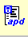
Step 7: Select to open case in ActivePaper

Step 8: Select “File Print PreviewDefault” and a Microsoft Word document will open
Step 9: Review the case for redactions if applicable

If the VICTIM(S) is requesting the report:
- Redact any personal information that does not pertain to them, ex) a separate victim
- If the person you are releasing to is NOT victim #1, make sure to redact victim #1’s name out of the header of the report.
- Redact the arrestee’s personal information except for name and DOB. That is public record.
- If there are any juveniles in the report redact ALL information pertaining to the juvenile, * If the Juvenile is a suspect or the victim of a sex crime the report is NOT releasable*
- If there are “others” and “witnesses” listed in the report who are adults, redact all personal information, except for their name.
- If other victims are in the report, their name will be under the property section. Redact their name out of the property section.
- Read the narrative of the report.
- Leave the origin, synopsis and statement of person you are releasing to
- Redact any investigative or police tactic material
- Redact the name and DOB of any juveniles (if applicable)
- Redact any statements, etc. not made by the person requesting the report
- After the redactions have been completed, print two copies of the report. One copy will go the requestor and one copy is to scanned into RMS with the request.
- Finish the mail request by either calling the victim for pickup or mailing the report to the address listed in the report. We do NOT email any reports.

If the ARRESTEE(S) is requesting the report:
- Ensure that the case has been adjudicated either in SDLaw or a CRE. The CRE will be attached to the case in NetRMS.
SDLaw Adjudication Steps:
Step 1: Open SDLaw, select “Other Agencies”
Step 2: Login, user ID is: “cb____”. Agency is “Carlsbad PD”
Step 3: Select “eSUN Web”
Step 4: Select “Carlsbad Records”, Select “OK”
Step 5: Select “County” from the left hand side of the screen
Step 6: Select “DA Name and Case Search” (DA09)
Step 7: Enter Last Name, First Name and Date of Birth into the fields
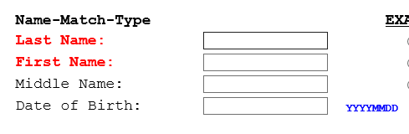

Step 8: Select “Search”
Step 9: Your search results will yield other cases, make sure to choose the correct case.

Step 10:

If the DISTRICT ATTORNEY is requesting the report:
- Print the entire case, nothing needs to be redacted
- Finish the request by faxing, emailing through secure link or putting in the court run

If another LAW ENFORCEMENT AGENCY (CORI) is requesting the report:
- A request must be received from the agency by either fax or email on their agency’s letterhead. The request should state why they need a copy of our report.
- Ensure that the Law Enforcement Agency is in the CORI book (Green Binder)
- Print the .1, nothing needs to be redacted
- If they need more than the .1 they can request it from and the request will be reviewed
- Finish the request by faxing or emailing through secure link

MAIL PROCEDURE FOR CRIME REPORT RELEASES:

Who to release to: Victim(s), District Attorneys, law enforcement agencies (CORI), and insurance companies

What to release: Victim(s) are entitled to the .1 report. Any report after the .1 is considered investigative and not releasable. Sometimes a .2 is written to correct a name, phone number, add property, etc, which is releasable. The District Attorney is entitled to the entire case. Law enforcement agencies are entitled to the .1. If they need more, they can request it. Insurance companies are entitled to the .1.

Where to find cases: NetRMS (cases 17-02002 and above) and Case Files (cases 17-02001 and below)

NetRMS Steps:
Step 1: Open NetRMS, select “Secure”
Step 2: Under the Records section, select “Case Files”
Step 3: In the top left hand corner, select “? Search”
Step 4: In the “*Case Number” field, enter the case number without hyphen
ex) 2001634
Step 5: Select to open case file

Step 6: Ensure the status of the .1 is “Approved”
Step 7: Select to open case in ActivePaper

Step 8: Select “File Print PreviewDefault” and a Microsoft Word document will open
Step 9: Review the case for redactions if applicable

If the VICTIM(S) is requesting the report:
- Redact any personal information that does not pertain to them, ex) a separate victim
- If the person you are releasing to is NOT victim #1, make sure to redact victim #1’s name out of the header of the report.
- If there is a suspect (known or unknown) redact ALL information pertaining to the suspect.
- If there are any juveniles in the report redact ALL information pertaining to the juvenile, * If the Juvenile is a suspect or the victim of a sex crime the report is NOT releasable*
- If there are “others” and “witnesses” listed in the report who are adults, redact all personal information, except for their name.
- If other victims are in the report, their name will be under the property section. Redact their name out of the property section.
- Read the narrative of the report.
- Leave the origin, synopsis and statement of person you are releasing to
- Redact any investigative or police tactic material
- Redact the name and DOB of any juveniles (if applicable)
- Redact any statements, etc. not made by the person requesting the report
- After the redactions have been completed, print two copies of the report. One copy will go the requestor and one copy is to scanned into RMS with the request.
- Finish the mail request by either calling the victim for pickup or mailing the report to the address listed in the report. We do NOT email any reports.

If the DISTRICT ATTORNEY is requesting the report:
- Print the entire case, nothing needs to be redacted
- Finish the request by faxing, emailing through secure link or putting in the court run

If another LAW ENFORCEMENT AGENCY (CORI) is requesting the report:
- A request must be received from the agency by either fax or email on their agency’s letterhead. The request should state why they need a copy of our report.
- Ensure that the Law Enforcement Agency is in the CORI book (Green Binder)
- Print the .1, nothing needs to be redacted
- If they need more than the .1 they can request it from and the request will be reviewed
- Finish the request by faxing or emailing through secure link

If an INSURANCE company is requesting the report:
- A request must be received by mail including a check for the cost of the report
- On the records request, verify that their insured is entitled to a copy
- Insurance companies are NOT always entitled to a copy of the report. Make sure they have a right and need to know, ex) property loss
- Some cases that insurance companies request are still under investigation. Contact the detective assigned to the case to ensure releasing the report will no compromise the investigation
- Redact any personal information that does not pertain to their insured, ex) a separate insured
- If there is a suspect (known or unknown) redact ALL information pertaining to the suspect

- If there are any juveniles in the report redact ALL information pertaining to the juvenile, * If the Juvenile is a suspect or the victim of a sex crime the report is NOT releasable*
- If there are “others” and “witnesses” listed in the report who are adults, redact all personal information, except for their name.
- If other victims are in the report, their name will be under the property section. Redact their name out of the property section.
- Read the narrative of the report.
- Leave the origin, synopsis and statement of person you are releasing to
- Redact any investigative or police tactic material
- Redact the name and DOB of any juveniles (if applicable)
- Redact any statements, etc. not made by the person requesting the report
- After the redactions have been completed, print two copies of the report. One copy will go the requestor and one copy is to scanned into RMS with the request.
- Finish the mail request by either calling the victim for pickup or mailing the report to the address listed in the report. We do NOT email any reports.

MAIL PROCEDURE FOR TRAFFIC ACCIDENT REPORT RELEASES:
Who to release to: Driver(s), passenger(s), registered owner(s) of vehicles involved, insurance company, law firm with client waiver

Where to find cases: Crossroads (if case number has 4 numbers at the end, ex) 20-01635) or CAD (if incident number has 5 numbers at the end, ex) 200020836)

Crossroads Steps:
Step 1: Open crossroads
Step 2: Login, username is “cb_____”, password is the
same, select login
Step 3: Select “Collision List”
Step 4: Select to search for the case number

Step 5: Enter case number with the hyphen,
ex) 20-01635
Step 6: Select to search for the case number

Step 7: Ensure the status is “Approved”
Step 8: Select the case and a preview will open
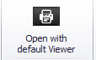
Step 9: Select to open the case in PDF

Step 10: Print the case
Step 11: Review case for redactions if applicable
- The narrative is the ONLY section that needs to be redacted in a traffic collision report
- Read the narrative
- Redact any BAC levels, mentions of specific drug use and mentions of sending the report to the District Attorney’s Office
Step 12: If applicable, once the report is redacted make a copy.
Step 13: Finish the mail request by either calling the requestor for pickup or mailing the report to a law firm or insurance company.

CAD Steps:

Step 1: Select “Service”, a dropdown menu will appear
Step 2: From the dropdown menu, select “Query Incident History Form”
Step 3: In the “IHQ” box, enter incident number with a # at the beginning,
ex) #200020836
Step 4: Print the incident using the printer icon in the top right corner of the page
Step 5: Review incident for redactions if applicable
- Read the incident
- In the incident, dispatch will run the parties involved. Redact any mention of any party having a “4th waiver, probation, TRO etc...”
- Redact any mentions of mental illness assumptions ex) RP believes other driver might have mental illness because of erratic behavior or ex) Driver is possible 5150
- At the very bottom of the incident it shows the callers of the incident. Redact that person if they were not involved in the traffic collision, ex) passerby
Step 6: If applicable, once the report is redacted make a copy.
Step 7: Finish the mail request by either calling the requestor for pickup or mailing the report to a law firm or insurance company.

HOW TO APPROVE REPORTS IN CROSSROADS:
Where to find cases: Crossroads
Crossroads Steps:
Step 1: Open crossroads
Step 2: Login, username is “cb_____”, password is the
same, select login
Step 3: Select “Collision List”
Step 4: Select “In Records”
Step 5: Click on the case.
Step 6: Select to view any comments left by Sgt’s for the reporting officer to
fix. If there is a comment, a red push pin will appear wherever a comment was made. Ensure the comment was fixed by the officer, then delete the comment. If the comment was NOT fixed, select “request changes” so the officer can fix the report.
Step 7: De-select to turn comment view off.
Step 8: Scroll through the report to ensure all the fields are appropriately filled out. If the Traffic Collision is a hit and run, the first name of the party should be “20002 CVC” and the last name should be “Unknown”. Ensure boxes are checked on the “coding” tab. Ensure the parties information is appropriately filled out on the “In.Wit.Pa.” tab. Ensure a sketch is on the “sketch” tab, unless it occurred on private property (which does not require a sketch). Ensure there is a narrative on the “narrative tab”.
Step 9: Select to approve the report.
Step 10: Repeat steps 4-9 until all the reports have been approved.
Step 11: In the top right hand corner, select to show supplemental reports.
Step 12: Select “In Records”
Step 13: Click on the case.
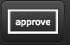
Step 14: Ensure there is a narrative.
Step 15: Select to approve the report.
HOW TO ADD CROSSROADS INTO NETRMS:
Step 1: From the Crossroads Home Screen, select . Select “Yes” to continue.
Step 2: A new window will appear. Login, username is “cb_____”, password is the
same, select login.
Step 3: Select “Configuration”
Step 4: From the left menu, select “Administrative Functions” (the first choice)
Step 5: From the right side menu, scroll to the very bottom and select, “Batch Print Collisions”. Select “Configure”
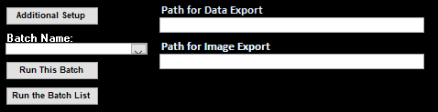
Step 6: A smaller black and white window will appear. Scroll to the bottom of the page. In the bottom left corner you will see this:

Step 7: From the drop down arrow under batch name, select NetRMS Collisions Batch.
Step 8: Select “Run This Batch”
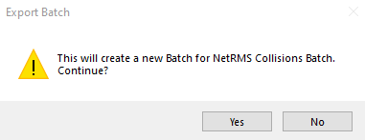
Step 9: This window will appear Select “Yes”

Step 10: A window will appear with the number of reports that have been converted to PDF.
Step 11: The PDF’s will automatically populate in the Q Drive under the NetRMS folder.
Step 12: Open the NetRMS folder in the Q Drive.
Step 13: Open RMS
Step 14: Enter the case number into RMS
Step 15: Select “Add Attachment”
Step 16: Name the attachment “Crossroads TC”
Step 17: Select “Browse” and choose the case you are attaching from the NetRMS folder. Select “Open”
Step 18: Select “Finish”
Step 19: Submit the attachment by selecting the “!”. This will make the attachment submitted.
Step 20: Select “Case Management” from the list on the left hand side.
Step 21: Select to verify the attachment.
Step 22: Select to approve the attachment.
Step 23: Select “Add Subfolder” and name it “Records”.
Step 24: If the Crossroads TC is a regular traffic accident (1181, 1182 or 1183) the case will be closed.
Step 25: Select “Edit Case Assignment”
Step 26: On the drop down under Action to Perform, select “Edit Case Assignment”. Select the currently assigned officer and select “Next”. In “Date Unassigned”, select the “Shift Key” and the “?” to enter the current date and time. Select Finish. Close that window.
Step 27: Select “Case Management”
Step 28: Select “Change Controlling Organization”
Step 29: Under “Choose the Organization” select “Records”
Step 30: Select “Select All”
Step 31: Select Finish. Close that window.
Step 32: Select “Return to Case”
Step 33: Select “Edit Case Details”
Step 34: On Case Status, choose “DC – Dept Closure”
Step 35: On Date Closed, select the “Shift Key” and the “?” to enter the current date and time.
Step 36: Select Save and Close.

***If the Crossroads TC is a hit and run (20002) follow the below steps***
Step 1: Select “Edit Case Assignment”
Step 2 : On the drop down under Action to Perform, select “Edit Case Assignment”. Select the currently assigned officer and select “Next”. In “Date Unassigned”, select the “Shift Key” and the “?” to enter the current date and time.
Step 3: On the drop down under Action to Perform, select “Add Case Assignment”. On the drop down “New Officer to Assign” add the traffic investigator. Select Next. In the “Date Assigned” select the “Shift Key” and the “?” to enter the current date and time. In the “Case Assignment Type” select “ADET – Assisting Detective”. Repeat these steps until both traffic investigators and the traffic sergeant are assigned. Select Finish.
Step 4: Select “Case Management”
Step 5: Select “Change Controlling Organization”
Step 6: Under “Choose the Organization” select “Traffic”
Step 7: Select “Select All”
Step 8: Select Finish. Close that window.

Coplogic

Initial review
- Log in, DORS – To Reviewing or Report Inbox
- Status: New or Resubmitted
- Prep screens with logs
  - Network – Records – CopLogic – Online Procedure
    - Online Tracking spreadsheet
    - Approve/Reject/Follow up documents for response templates
- Click Review, check report for:
  - No suspect info
  - Theft / lost property must be under $5k
  - Incident location must be in Carlsbad
    - If on the beach, only north of Pine St. is our jurisdiction, otherwise State Parks
    - Airport is also not our jurisdiction
  - Car unlocked
  - We do not take fraud or identity theft
  - We do not take for items stolen out of a dwelling or enclosed patio (burglary)
- If you need more information: follow up, replace text in brackets
  - “Thank you for your online report.” Then add text requesting more info.
Notes for property
- If a driver’s license number is provided, would take as report because it is identifiable information (similar to serial number)
- If a serial number is provided, requires case number
- 488/594 always require case number and entry into RMS, even if no serial number
- Lost property only gets a case number if a serial number is provided
- Hit & run is IO
- Graffiti – clarify ownership of location
- No license plates
Approved submissions
- Print
- CAD
  - Entry
    - Location of incident, RP info
    - Type:
      - LPROP
      - R20002 - hit & run
      - R488 - petty theft
      - R594 - vandalism
    - Summary in Comments, start with “Online Report” then date and time of incident
  - IO
    - Advanced – Enter Advised: “IO” – Enter
    - Get CAD #, write it on the report
  - For Case Number
    - Advanced – Enter Advised: “OLR” – Enter
    - Command window: CN[space].[5-digit incident #]
- CopLogic
  - Always “Approve with Note”
  - Enter info into Excel spreadsheet based on report number provided in CopLogic message
  - Copy from Word Doc, paste into message with case/incident number
    - For IO: replace “report” with “incident”
  - Add “online” to permanent case number
  - Remove *** section and “email us” sentence
  - Approve, print
    - For IO: Staple and file in brown folder in cabinet by printer
  - Replace number with case number
- RMS
  - Scan report and attach to case
  - Open case in RMS
  - Add Case Report
  - Admin tab
    - Bring forward from CFS, highlight, finish
    - Subject: “C/R [crime code] V/[victim last name]”
    - Report type: crime/incident
    - Enter created by
    - Enter occurred on (from report) with military time
      - Can leave “Between” field blank
  - Offense tab: add; fill required fields
    - 90000 for lost property w serial number
    - 488 for petty theft (from veh or all other larceny)
    - Completed: yes
    - Location type can be other/unknown (assigned parking spot)
  - Victim:
    - Type (individual)
      - Might be business if work property was stolen (RP becomes “other”)
    - Victim of: …Add, OK
    - Name, address (CSZ = city, state zip), resident (of CB), DOB, sex
    - Contact Info
    - Driver’s license number can go in Identification box
  - Property: new
    - Property (type), status (stolen/lost/damaged), #, $, P&E (no)
    - Make, model, color
    - Property relationships: victim, entity: space bar will pull victim names
  - Narrative:
    - “Online Report…” [2 enter for new lines]
    - Copy/paste from online report
  - Copy Subject from Admin tab to use for later
  - Save and Close
  - Edit Case Details – Paste Subject from report into Subject line in Case Detail
    - Save and Close
  - Check Report for Errors (E with red checkmark by report)
  - ! to submit
  - Case management – change controlling organization – select all – assign to the appropriate shift (based on current time) – Finish

- SDLaw: for items with serial numbers
  - eSun – State – Property – Single Record Entry
  - Look in property book for codes
    - Driver’s license = “I”; code = driver; Brand = Califo or check book for other state
    - Military card = i-creden
    - eBikes in SVS, see template in property book
  - OCA - case number with no dash
  - Date of transaction - first date reported (yyyyddmm)
  - Entry level code – leave default
  - Misc. info - brief description
  - Enter record – messages – print
  - Ask someone to double check
  - Scan and attach to case
- File printed online report (already scanned and attached) and property entry
Rejected submissions
- Print submission
- CAD
  - Still create a CAD call for anything that requires them speaking to an officer
    - Unless it’s something that is out of our jurisdiction
  - Entry
    - Location of incident, RP info
    - Type
    - Summary in Comments, start with “Online Report” then date and time of incident. Last sentence: Rejecting online report due to [reason]. RP was given incident number. Advised RP to contact dispatch.
    - Advanced – Enter Advised: “REJ” – Enter
    - Get CAD #, write it on the report to provide to RP with rejection
- CopLogic
  - Reject
  - Leave top section in
  - Copy/paste from Rejections Word Doc
Recovered Lost Property
- Get case number from Excel sheet
- RMS
  - Open case
    - Edit case details – open – save and close
  - Add Case Report
  - Click to bring forward from CFS, highlight, finish
  - Report type: Follow-Up
  - Created by
  - Confirm that offense was pulled forward
  - Victim tab
    - Click to bring forward a victim – Bring forward from Case – highlight, finish
  - Property tab
    - Click to bring forward property – bring forward from case – highlight, finish
    - Change status (from lost to found)
    - Date & Time: can use notification (email time)
  - Narrative tab
    - Brief description of recovery
  - Save and close
  - Check report for errors
  - ! to submit – ok
  - Change controlling organization for the new report only
    - Select the report, choose the organization (current shift)
- SDLaw
  - RMS – property entry to get FCN (file control number)
  - eSUN – State - Property
  - Back to SDLaw – Single Record Cancel
  - Enter FCN, OCA, and current date for cancellation – cancel record
  - Messages – New Messages
  - Run to confirm cancellation
    - State – SER/OAN inquiry
    - Enter serial number and type
    - Messages: check for No Record message
  - Select all messages and print
    - Write case number at top
    - Scan and attach

Oversized Vehicle Permits

The City of Carlsbad implemented an Oversized Vehicle Ordinance in March 2013. The city restricts overnight parking of recreational and oversized vehicles on city streets between the hours of 2:00 a.m. and 5:00 a.m. Every citation will be assessed a $50 penalty. The goal of the ordinance is to effectively manage the parking of RVs and oversized vehicles in the City of Carlsbad, and address the many complaints by residents, visitors and business owners associated with overnight parking of RVs on city streets.
The ordinance includes exceptions to accommodate the needs of city residents, their guests, and hotel or motel guests with RVs.
Residents and their guests can apply for an oversized vehicle permit, which must be displayed in the window when the vehicle is parked on a city street between hours of 2 to 5 a.m. The vehicle must be parked within 400 feet of the residence that was granted the permit. Following are the types of permits that will be granted:
- Yearly Residential Permit: City of Carlsbad residents who own an RV can apply for a yearly free permit to park their vehicle on a public street at their residence for up to 72 hours, four times within each month.
- Temporary 72 Hour Guest Permit: Carlsbad residents can apply for a temporary permit for their guest. This free permit would allow residents to have guests with an RV park at their residence for up to 72 hours, six times per year.
- Commercial Property Permit: Hotels or motels can allow guests to park RVs next to these inns on public streets if the RVs cannot be accommodated in the property’s parking lot. The city would issue each hotel and motel reusable permits that they can give to their guest.
- Oversized vehicle: The dimensions of an oversized vehicle are defined as either: 22 feet in length, or seven feet in height and seven feet in width.
The free permit can be obtained from the City of Carlsbad Police Department Monday through Friday from 8:00 a.m. to 5:00 p.m. The Police Department is located at 2560 Orion Way, 442-339-2119.

Fulfilling an Oversized Vehicle Request for a Resident
- We receive Oversized Vehicle Requests (OVP) from the US Mail, Email to the Records Email, and on a walk-in basis.
- We can email the application to the resident, and they can email the application and supporting documents back to the Records email. Required documents are Driver’s license, RV/Trailer registration, and proof of residency.
- Once we have the required documentation and application, we can prepare an OVP. Go to the OVP spreadsheet in excel.
- If a resident is requesting an OVP, enter the Residents name on the tab OVP Resident Log. Enter the address, license plate, phone number and email address in the first tab of the excel spreadsheet. Make a mental note of the OVP permit number.
- Go to the second tab, OVP Resident Print and change the permit number to the resident you are working on. The address and license plate will populate with the current resident information.
- If you are printing for the resident or mailing, go to file, then print. Use the color printer so it prints with the current years’ Permit color. Mail
- If you are sending through email, go to file, print, save as a pdf, open your email, and attach file. Write a short note indicating the OVP permit is attached.
Fulfilling an Oversized Vehicle Request for a Resident’s Guest
- Residents can request an OVP for their guests. The top of the application is the Resident’s information. The second part or the vehicle information would be information about the guest and their vehicle. Once we have the application, copy of the residents’ driver’s license, proof of residency, and guests vehicle registration, we can prepare the OVP spreadsheet in excel.
- Select the OVP Guest Log tab, enter the Residents name, resident’s address, phone number and email address in the excel spreadsheet. Enter the guest’s license plate, Guest name, and Date of Stay. Make a mental note of the OVP permit number.
- Go to the tab, OVP Resident Print and change the permit number to the resident you are working on. The address and license plate will populate with the new resident information.
- If you are printing it to give to resident or mailing, go to file, then print. Use the color printer so it prints with the current years’ Permit color. If resident is in the lobby, give them the OVP permit. If you need to mail the OVP, make a label and send it off in the mail.
- If you are sending through email, go to file, print, save as a pdf, open your email, and attach file. Write a short note indicating the OVP permit is attached.

Fulfilling an Oversized Vehicle Request for a Guest at a Hotel or Motel
- On rare occasions, guests of certain local hotels need an OVP because the hotel cannot accommodate the RV parking on the property.
- The hotel must call us to give us the hotel room, guest name, address, phone number, and vehicle information
- Once we have the documentation required, go to the OVP spreadsheet in excel.
- Select the OVP Guest Log tab, enter the Hotel name, Hotel address, contact name, phone number and email address in the excel spreadsheet. Enter the guest’s license plate, Guest name, and Date of Stay. Make a mental note of the OVP permit number.
- Go to the tab, OVP Resident Print and change the permit number to the resident you are working on. The address and license plate will populate with the new resident information.
- We could print the permit to be later picked up by the hotel guest. Place it in the green folder at the cashier’s desk for the guest to pick up. Emailing might be an option too as long as they can print the permit.
Print the OVP Permit and place it in the green folder at the cashier’s desk. The guest can pick up at the counter.

CHP 180s
- Open case in NetRMS
- Click “Add Impound Report”
- Bring forward information by clicking on the link at the bottom of the page
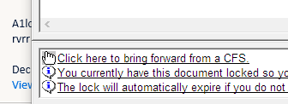
- Double click on related call to carry forward information
- Verify “Beat” was entered
- Click “Finish”
- Click on Impound Tab
- Make sure notice(s) of stolen vehicle were sent (RO, LO, or both), if not then send notice(s)
- Complete the following:
  - Notice(s) Sent On
  - Notice(s) Sent By (with CB####)
  - Impound Date/Time
  - Location Towed/Recovered From
  - Beat

- Under Storage Detail complete the following:
  - Tow Company (listed on report)
  - Storage Location
  - Storage Location CSZ (city, state, zip)
  - Storage Authority (listed on report)
  - Storage Officer ID (cb####)

- Go to the Person/Entity Tab, click on the “New Entity” bar and complete the following in the dropdown:
  - Entity Type (RO or LO)
  - Name – verify with teletypes
  - Address – (for RO or LO)

- Go to Vehicle/Vessel Tab and complete the following:
  - Property Type (choose from dropdown)
  - Plate Clear in SVS – yes/no
  - Plate Number
  - Number of Plates
  - License State
  - Registration Expires
  - Year
  - Make
  - Model
  - Style (example: pk/pick-up, LL/SUV)
  - Property
    - Relationships – LO/RO
    - Entity – hit #

- Go to Narrative Tab
  - Type in “See attached CHP 180”

- Save and Close

- Submit report

- Re-open document, print out and send vehicle notice to owner

- To close out report; no report to follow/no arrest

  - Go to ‘Edit Case Assignment’ - unassign officer
  - Go to ‘Edit Case Details’ – enter “CHP 180” in the subject line
  - Go to ‘Case Status’ – select “Dept. Closure” and enter date closed

