|  |  |
| --- | --- |
| Exploration HUB July | 2023 |

|  |  |  |  |  |  |
| --- | --- | --- | --- | --- | --- |
| Monday | Tuesday | Wednesday | Thursday | Friday | Saturday |
|  |  |  |  |  | **1** |
|  |  |  |  |  |  |
| **3** | **4** | **5** | **6** | **7** | **8** |
|  | All Carlsbad City Libraries Closed |  |  |  | Digital Conversion Demo  noon – 1 p.m. |
| **10** | **11** | **12** | **13** | **14** | **15** |
|  |  | Photo Scanner Demo  5:30 – 6:30 p.m. | Tinkercad 3D Design: Writer’s Dice  5 – 6:30 p.m. |  |  |
| **17** | **18** | **19** | **20** | **21** | **22** |
| Digital Conversion Demo  5:30 – 6:30 p.m. | Silhouette Cameo: Shadow Box with 3D Paper Layers  5 – 6:30 p.m. |  | Silhouette Cameo: “Change the World” Jar  5 – 6:30 p.m. |  |  |
| **24** | **25** | **26** | **27** | **28** | **29** |
|  | Teen Silhouette Cameo: Shadow Box with 3D Paper Layers (Grades 7-12)  4 – 5:30 p.m. | Tinkercad 3D Design: Personalized Guitar Pick  5:30 – 6:30 p.m. | Beginning Arduino  5:30 – 6:30 p.m. |  |  |
| **31** |  |  |  |  |  |
| Photo Scanner Demo  11 a.m. – noon |  |  |  |  |  |

Summer Reading Adventure class

Register for class here

**Exploration HUB July 2023**

Learn • Collaborate • Create

**Monday – Thursday:**

11 a.m. – 6:30 p.m.

**Friday & Saturday:**

11 a.m.– 4:30 p.m.

**Exploration HUB Website:**

**www.carlsbadca.gov/hub**

Classes are for ages 13 and up

unless otherwise indicated.

All classes in the Exploration

HUB are free.

1775 Dove Ln.

Carlsbad, CA 92011

Located on the 2nd floor

442-339-2039

**Class Schedule**

**Summer Reading Adventure Class**

**Digital Conversion Demo: VHS tapes, Super 8 and more**

7/8/2023 noon – 1 p.m. or 7/17/2023 5:30 – 6:30 p.m.

Learn how to convert old VHS tapes, Super 8 or 8mm reels, mini DV tapes or Hi8 tapes to .mp4 files using various equipment and software.

**Photo Scanner Demo**

7/12/2023 5:30 – 6:30 p.m. or 7/31/2023 11 a.m. - noon

Learn how to use the Epson V850 scanner and software to digitize your negatives, slides and photos.

**Tinkercad 3D Design: Writer’s Dice**

7/13/2023 5 – 6:30 p.m.

Get an introduction to 3D design and learn how to create writer’s dice based on the 5 W’s (Who, What, Where, When and Why). Add text to different sides of a cube and roll them for writing prompts.

**Silhouette Cameo: Shadow Box with 3D Paper Layers**

7/18/2023 5 – 6:30 p.m.

Learn how to use the Silhouette Cameo software and cutter to create a piece of art. The design will be cut out on cardstock and layered inside a shadow box.

**Silhouette Cameo: “Change the World” Jar**

7/20/2023 5 – 6:30 p.m.

Learn how to use the Silhouette Cameo software and cutter to create text that will be cut out on adhesive vinyl and adhered to a jar. Save those coins and bills and make a change in the world.

**Teen Silhouette Cameo: Shadow Box with 3D Paper Layers**

**(Grades 7-12)**

7/25/2023 4 – 5:30 p.m.

Teens going into grades 7-12 can create a piece of art using Silhouette Cameo design software and cutter. The design will be cut out on cardstock and layered inside a shadow box.

**Tinkercad 3D Design: Personalized Guitar Pick**

7/26/2023 5:30 – 6:30 p.m.

Get an introduction to 3D design and learn how to manipulate shapes to create a guitar pick. It will be printed on the Dremel 3D printer.

**Beginning Arduino**

7/27/2023 5:30 – 6:30 p.m.

Interested in circuitry, coding and electronics? Get hands on experience with the Arduino circuit board and learn how to upload computer code to it. No prior experience necessary and Arduino kits will be provided.

**Summer Reading Adventure**

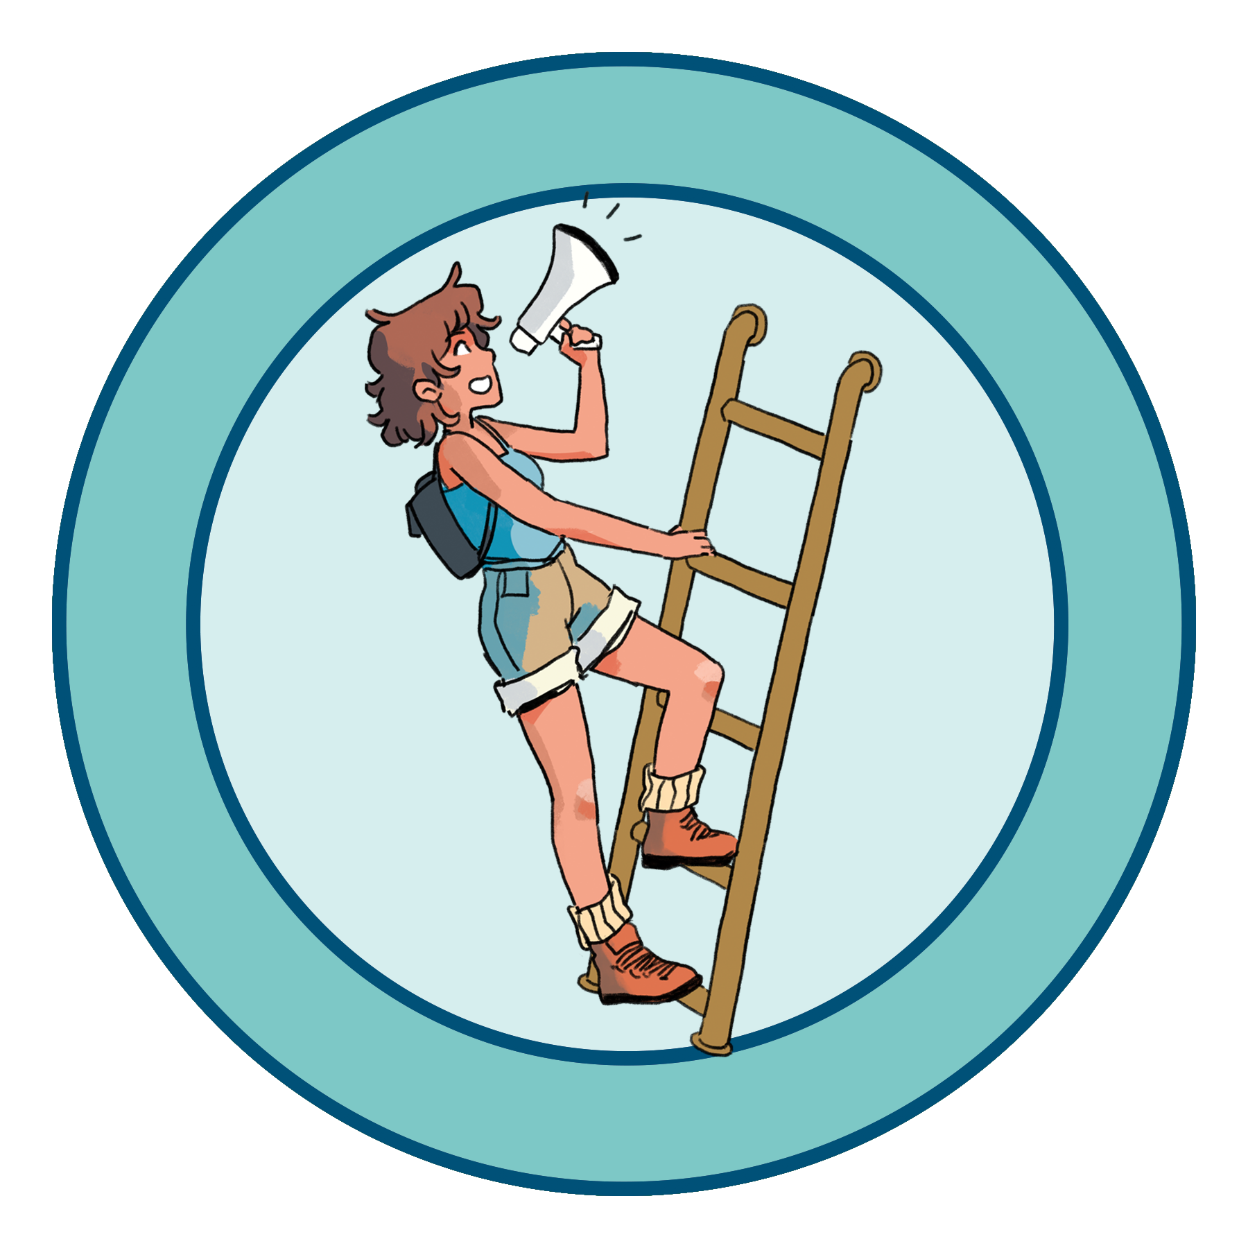

**June 20 – Aug. 5**

Readers of all ages can earn incentives as they learn, read and participate throughout the summer. This year’s theme, “Find Your Voice,” encourages patrons to share stories, create art, make music and use their voices for good.

sra.carlsbadca.gov